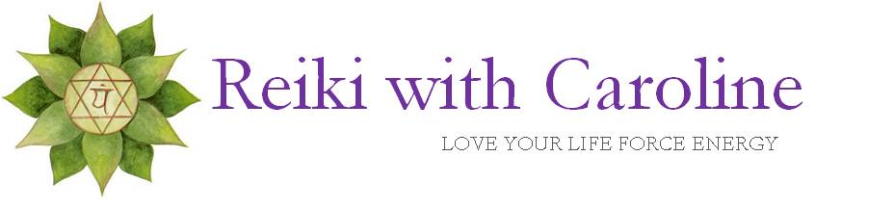
REIKI WITH CAROLINE 2023 PRICELIST

Reiki One 2 One- with Caroline in the Re-Energize You Studio
1hour 15min £45
Reiki Express with Caroline in the Re-Energize You Studio
30 min £30
Remote Reiki Online with Caroline via Zoom-perfect for international clients, or as an interim appointment or if too poorly to attend in person.
35 min £25

REIKI 1 – a one day course One2One with Caroline in the Re-Energize You Studio. Lunch, manual and certificate provided.
9.00pm-4.00pm £145

REIKI 2- a one day course One2One with Caroline in the Re-Energize You studio. Lunch, manual and certificate provided.
9.00pm-4.00pm £195

CRYSTAL HEALING WITH CAROLINE

Crystal Re-Balance with Caroline in the Re-Energize You Studio
1hour 15min £45
Crystal Express with Caroline in the Re-Energize You Studio
30 min £30
Guided Group Meditation with Crystals & Reiki, Online with Caroline via Zoom
40 mins £7

Re-Energize You 2023 Price List

ASTROLOGY WITH CAROLINE
Astrology One 2 One birth chart -in person reading with Caroline in the Re-Energize You Studio or online via Zoom. You receive an audio MP3 recording and laminated birth chart. *Time of birth required
1 hour £45
Astrology One 2 One 3 month forecast- in person reading with Caroline in the Re-Energize You Studio or online via Zoom. You receive an audio MP3 recording *Must have had a prior birth chart reading with Caroline
1 hour £45
Astrology S.O.S- An express reading with Caroline for existing clients who need clarity and guidance on what’s happening now in a particular area of their life. Online, telephone, video or MP3 recording. *Must have had a prior birth chart reading with Caroline
20 mins £25

Astrology Mini- in person or online reading with Caroline. Discover your main element: earth, air, fire or water and take a deep dive into your Sun and Moon sign. A fun introduction into astrology!
You receive an element chart. Perfect for children, Astrology Parties, fayres and corporate events! 15mins £20
Follow Caroline’s Energy of the Day posts on social media- FREE! Instagram @re_energize_you Facebook facebook.com/energizewithcaroline

RE- ENERGIZE YOU BESPOKE COMBINATIONS

Astro-Reiki Deluxe– Astrology One-2 One followed by a Re-Energizing Reiki with Caroline.
2 hours £85

Astro-Reiki– Astrology Mini followed by a Reiki Express
1 hour £50
******************** INTRODUCING *********************
Re-Energize You Mini Retreat(half day)

Give yourself or a loved one the gift of a morning or afternoon for the ultimate investment in energetic wellbeing! One 2 One with Caroline at the Re-Energize You Studio

- a wellness or spiritual guided chakra meditation,
- your wheel of life assessment,
- an astrology reading,
- a reiki crystal healing
- Healthy refreshments provided.
*Time of birth required for astrology reading
3 hours £135

