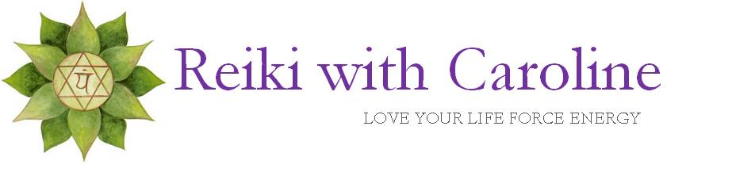

Fees
As a Reiki Practitioner, I only charge for my time, not the Reiki energy as ethically this is a Universal Energy flowing through all of us. That said, as the Reiki treatment is an investment of my time and energy and as such it should be recognized with a fee. I do offer a reduced rate for students, unemployed, senior citizens, members of Equity, AEA and SAG.

U.S fees
One 2 One treatment: $50 for 1hr 15 min session. ($35 reduced fee)
Remote Reiki: $25 ($17 reduced fee)

U.K fees
One 2 One treatment: 40 GBP for 1hr 15 min (30 GBP reduced fee)
Remote Reiki: 20GBP (15GBP reduced fee)

Please contact me via email www.info@reikiwithcaroline for bank details.
I accept cash or check, payable to Caroline Baker-Duly for One 2 One sessions.
Travel expenses may be added if booking an at home One 2 One Reiki session.

